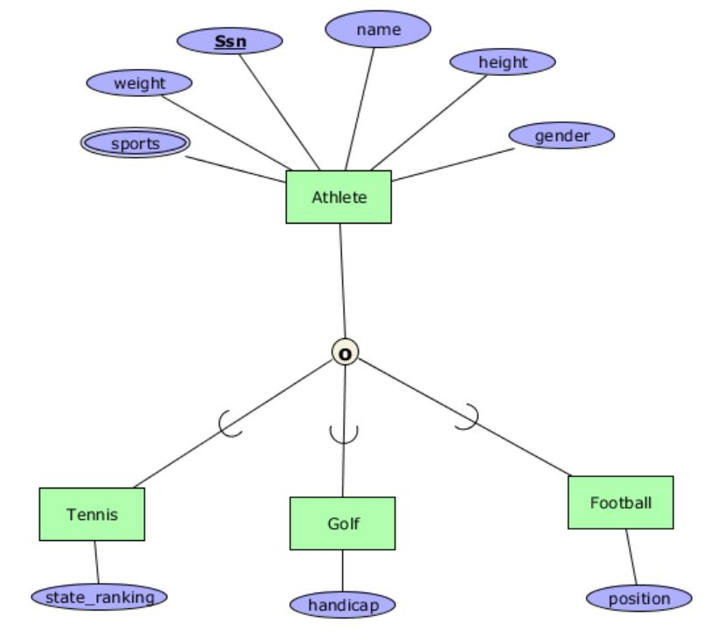

Mô hình quan hệ:

Athlete(Ssn,name,height,weight,gender)

Athlete_Sports(Ssn,sports)

Tennis(state_ranking,Ssn)

Golf(handicap,Ssn)

Football(position,Ssn)

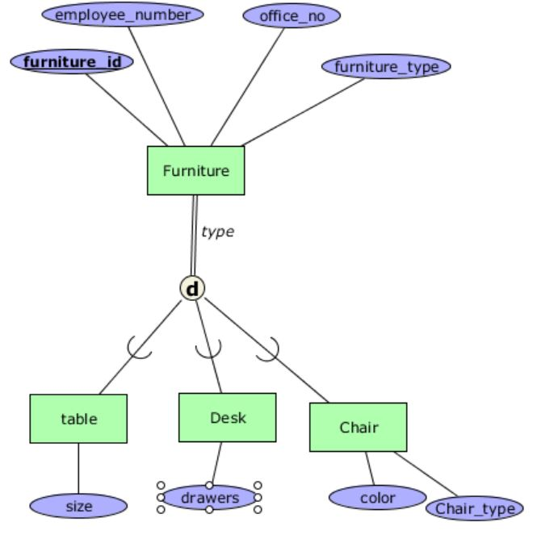

Mô hình quan hệ:

Furniture(furniture_id,employee_number,office_no,furniture_type)

Table(furniture_id, size)

Desk(furniture_id, drawers)

Chair(color,chair_type, furniture_id)

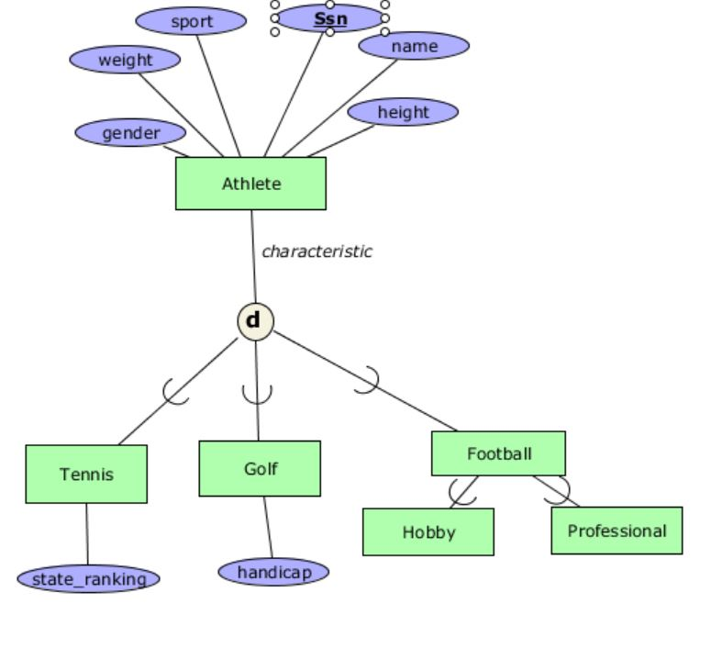

Mô hình quan hệ:

Athlete(Ssn,name,height,weight,gender,sport)

Tennis(state_ranking,Ssn)

Golf(handicap,Ssn)

Football(position,Ssn)

Hobby(Ssn)

Professional(Ssn)

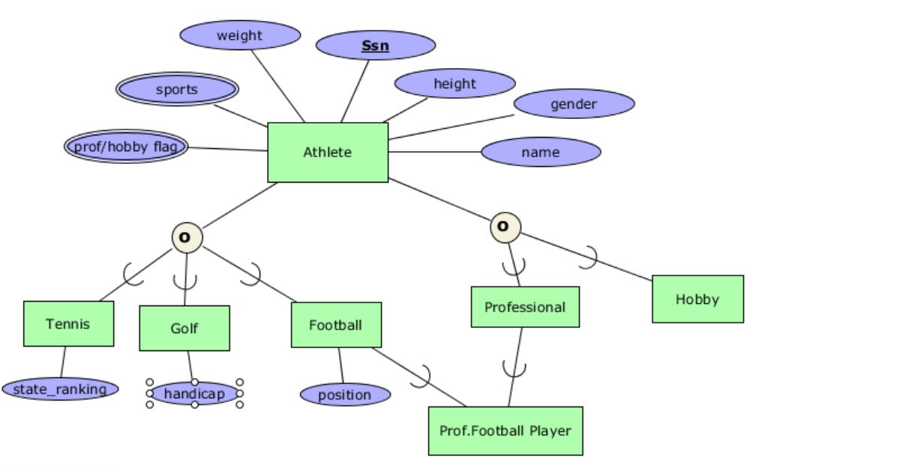

Mô hình quan hệ:

Athlete(Ssn,name,height,weight,gender)

Athlete_Sports(Ssn,sports)

Athlete_prof/hobbyflag(Ssn, prof/hobbyflag)

Tennis(state_ranking,Ssn)

Golf(handicap,Ssn)

Football(position,Ssn)

Hobby(Ssn)

Professional(Ssn)

Prof.FootballPlayer(Ssn)